08/06/2025
Curriculum Vitae

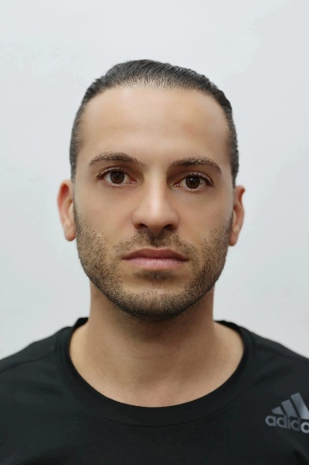
Name: Rami Saffuri
Passport No: 31677870
Israeli ID No: 301357679
Birth place: Israel
Birth date: 14/12/1987
Address: Shfaram, Alfuar 15 / 1
Mobile Phone: +972-528617004
E-Mail: ramisaffuri@gmail.com
Marital Status: single

Education, Courses, Continuing Education Programs, Accreditations
Years | Degree / Diploma | Institution Name
2010 – 2015 | B.A. in Computer Science and Mathematics & Teaching Certificate | The Arabic College of Education of Israel – Haifa
2015 – 2017 | M.A. in Education Systems Development | University of Haifa
2018 – 2019 | M.A. in Political Science | University of Haifa
2019 - 2022 | LL.B Bachelor of Laws | Ono Academic College
2022 – 2024 | LL.M Master of Laws | Ono Academic College
2023 - 2025 | M.B.A Master of Business Administration | Ono Academic College
2019 - 2025 | PhD Student  Doctoral domain: Marketing | Alexandru Ioan Cuza "University of Iasi, Romania"

Work Experience
Years | Organization | Function and Responsibilities
2014 - 2016 | Al – Ruad School | Computers Teacher and Telecommuting Coordinator
2016 - 2025 | Janat Al-Sijar Association | CEO and Telecommuting Coordinator
2022 - 2024 | Taha Riyad, Adv. & Notary Office | Internship at a law firm

Languages (Excellent / Good / Weak)
Language | Writing | Reading | Speaking
Hebrew | Excellent | Excellent | Excellent
Arabic | Excellent | Excellent | Excellent
English | Good | Good | Good

Scientific Publications and Conferences Participation
NO. | Title | Date
1 | Scientific Paper:  Saffuri, R. (2025). The Politics of Education: Social Pressure and Political Influence in Arab Local Authorities. SEA-Practical Application of Science, 13(38), 71-76.‏  https://seaopenresearch.eu/Journals/articles/SPAS_38_1.pdf | 2025
2 | Scientific Paper:  Saffuri, R. (2025). Women in Management Positions in Schools in The Arab Society in Israel. Cross-Cultural Management Journal, 27(1), 17.‏  https://seaopenresearch.eu/Journals/articles/CMJ2025_I1_3.pdf | 2025
3 | Scientific Paper:  Saffuri, R. (2024). Non-Formal Education in Arab Local Authorities in Israel: Scope, Challenges, and Impact on the Younger Generation. Management Intercultural, (53), 97-111.‏  https://seaopenresearch.eu/Journals/articles/MI_53_5.pdf | 2024
4 | Scientific Paper:  Saffuri, R. (2025). The Arab Local Authorities in Israel and Their Impact on the Education System: Between Powers and Limitations. SEA-Practical Application of Science, 13(37), 25-29.  https://seaopenresearch.eu/Journals/articles/SPAS_37_3.pdf‏ | 2025
5 | Scientific Paper:  Saffuri, R. (2024). Appointing Officials in Local Authorities in the Arab Society in the State of Israel. Cross-Cultural Management Journal, XXVI, 2, 207-212.  https://seaopenresearch.eu/Journals/articles/CMJ2024_I2_9.pdf‏ | 2024
6 | Scientific Paper:  Saffuri, R. (2024). The Complex Landscape of School Principal Appointment in the Israeli Arab Education System. SEA-Practical Application of Science, 12(36), 257-261.  ‏ https://seaopenresearch.eu/Journals/articles/SPAS_36_10.pdf | 2024
7 | Scientific Paper:  Saffuri, R. (2025). The Arab Local Authorities in Israel and Their Impact on the Education System: Between Powers and Limitations. SEA - Practical Application of Science, Year (volume) XIII (37), 25-29. https://spas.seaopenresearch.eu/articles/spas_37_3 | 2025
8 | Participation in the international conference:  First Generation for higher education  2021 of the University of Tel Aviv  https://docs.google.com/forms/d/e/1FAIpQLSdUu-NctgAK4v9TvPhx8VBcWR_HuxEABQm2B-xmCrbJGZgOAQ/viewform  Confirmation attached | April 2021
9 | Participation in the international conference:  The 6th Kinneret Conference on Education, Academia and Periphery, Topic: Communities in the perspective of time.  LITERATURE REVIEW AND RESEARCH GOALS. (preparing the presentation and the attendance to the conference).  https://www.getwebinar.co.il/lp/kinneret202103/  Confirmation attached | March 2021
10 | Participation in the international conference:  Education and Academia, Topic: Women's Leadership and Entrepreneurship in the COVID Era.  LITERATURE REVIEW AND RESEARCH GOALS. (preparing the presentation and the attendance to the conference).  https://w3.braude.ac.il/event/maasikim/  Confirmation attached | April 2021
11 | Participation in the international conference:  Education and Academia, Topic: Opportunities and Collaborations Between Industry and Academia.  LITERATURE REVIEW AND RESEARCH GOALS AND METHADOLOGY. (preparing the presentation and the attendance to the conference).  https://w3.braude.ac.il/event/indus-acad/  Confirmation attached | March 2022
12 | Participation in the international conference:  The Northern Conference for Technological Progress and Social Justice  2021.  LITERATURE REVIEW AND RESEARCH GOALS. (preparing the presentation and the attendance to the conference).  https://w3.braude.ac.il/event/north202/  Confirmation attached | November 2021
13 | Participation in the international conference:  Software & Data.  https://www.aeai.org.il/software-data-conference-2021/  Confirmation attached | July 2021

Rami Saffuri


